**Lab 3**

**Implementation of different types of LAN topology with IP addressing using PT**

**Objectives:**

* Design the following topology in Packet Tracer.
* Subnet each of the network with the IP and complete the following table.
* Assign the appropriate IP into each of the network.
* Add one more PC to each of router and assign IP.
* Test connectivity between PC in a router.

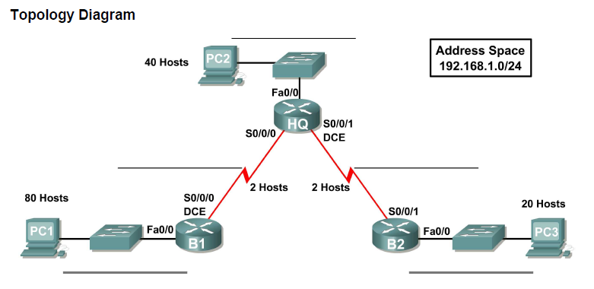

**1st subnet (80 hosts)**

* 192.168.1.0 /24
* Required hosts 80= 27 =128 hosts
* Subnet mask= 11111111. 11111111.11111111. 10000000 =255.255.255.128
* N.A = 192.168.1.0 /25
* B.A = 192.168.1.127 /25

**2nd subnet (40 hosts)**

* 192.168.1.128 /26
* Required hosts 40= 26 =64 hosts
* Subnet mask= 11111111. 11111111.11111111. 11000000 =255.255.255.192
* N.A = 192.168.1.128 /26
* B.A = 192.168.1.191 /26

**3rd subnet (20 hosts)**

* 192.168.1.192 /27
* Required hosts 20= 25 =32 hosts
* Subnet mask= 11111111. 11111111.11111111. 11100000 =255.255.255.224
* N.A = 192.168.1.192 /27
* B.A = 192.168.1.223 /27

**4th  subnet (2 hosts)**

* 192.168.1.224 /30
* Required hosts 2= 22 =4 hosts
* Subnet mask= 11111111. 11111111.11111111. 11111100 =255.255.255.252
* N.A = 192.168.1.224 /30
* B.A = 192.168.1.227/30

**5th subnet (2 hosts)**

* 192.168.1.228 /30
* Required hosts 2= 22 =4 hosts
* Subnet mask= 11111111. 11111111.11111111. 11111100 =255.255.255.252
* N.A = 192.168.1.228 /30
* B.A = 192.168.1.231/30

**Subnet Table**

|  |  |  |  |  |
| --- | --- | --- | --- | --- |
| **Subnet** | **Assignable Adress Range** | **Subnet Mask** | **Subnet Address** | **Broadcast Address** |
| 1st subnet (80 hosts) | 192.168.1.1 /25 -192.168.1.126 /25 | 255.255.255.128 | 192.168.1.0 /25 | 192.168.1.127 /25 |
| 2nd subnet (40 hosts) | 192.168.1.129 /26 - 192.168.1.190 /26 | 255.255.255.192 | 192.168.1.128 /26 | 192.168.1.191 /26 |
| 3rd subnet (20 hosts) | 192.168.1.193 /27-  192.168.1.222 /27 | 255.255.255.224 | 192.168.1.192 /27 | 192.168.1.223 /27 |
| 4th subnet (2 hosts) | 192.168.1.225 /30-  192.168.1.226/30 | 255.255.255.252 | 192.168.1.224 /30 | 192.168.1.227/30 |
| 5thsubnet  (2 hosts) | 192.168.1.229/30- 192.168.1.230/30 | 255.255.255.252 | 192.168.1.228 /30 | 192.168.1.231 /30 |

**Addressing table**

|  |  |  |  |  |
| --- | --- | --- | --- | --- |
| **Device** | **Interface** | **IP address** | **Subnet mask** | **Default Gateway** |
| **HQ** | Fast ethernet 0/0 | 192.168.1.190 /26 | 255.255.255.192 | N/A |
| Serial 2/0 | 192.168.1.225 /30 | 255.255.255.252 |
| Serial 3/0 | 192.168.1.229/30 | 255.255.255.252 |
| **B1** | Fast ethernet 0/0 | 192.168.1.126 /25 | 255.255.255.128 |  |
| Serial 2/0 | 192.168.1.226/30 | 255.255.255.252 |
| **B2** | Fast ethernet 0/0 | 192.168.1.222 /27 | 255.255.255.224 |  |
| Serial 3/0 | 192.168.1.230/30 | 255.255.255.252 |
| **PC1** | N/A | 192.168.1.1 /25 | 255.255.255.128 | 192.168.1.126 /25 |
| **PC2** | N/A | 192.168.1.129 /26 | 255.255.255.192 | 192.168.1.190 /26 |
| **PC3** |  | 192.168.1.193/27 | 255.255.255.224 | 192.168.1.222 /27 |



**Md. Tasriful Hoque Mozumder**

**ID: CSE 06607652**